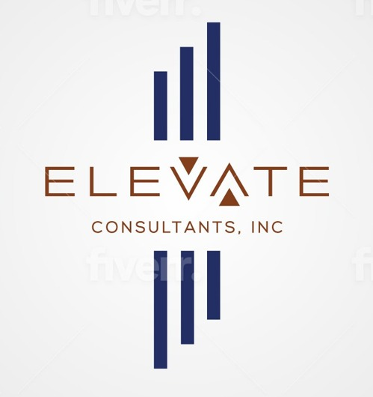
ELEVATE CONSULTANTS, INC.
Environmental Compliance & Risk Consulting
Project Intake Form
This form gathers what we need to prepare an accurate proposal. Complete Section 1 and 2, check off the services you need in Section 3 and answer only the follow-up questions under those services, then complete Sections 4 through 6.
§1 Contact Information
Full Name * | Company / Entity
Your Role  Owner, property manager, board member, architect, GC, attorney/broker, tenant, other | Preferred Contact Method  Phone / Email / Text
Email * | Phone Number *
§2 Property Information
Project Address *

City / Borough * | Property Type *
Building Occupied?  Yes / No / Partially | Approximate Square Footage
What is prompting this project?
Renovation, sale/purchase, refinance, violation notice, tenant complaint, routine compliance, insurance, other

Project Start Date | Desired Completion Date
§3 Scope of Work
Check every service you need. Answer only the questions listed under the services you've checked.
☐ Asbestos Survey / Investigation
Renovation, demolition, or maintenance-related testing
Type of work planned (renovation, demolition, plumbing, mechanical, electrical, roofing, façade, maintenance, due diligence)

Previous asbestos survey on file? (Yes/No)

DOB job number / PW1 (if available)

Areas being renovated / affected

Known asbestos-containing materials? (Yes/No/Unsure)

Materials expected to be disturbed

Is abatement anticipated? (Yes/No/Unsure)

Turnaround requested (Standard / 48-hour / 24-hour)

☐ NYC DEP ACP-5 Filing
New filing, amendment, update, or ACP-21 coordination
Existing asbestos survey? (Yes/No)

Filing type (New ACP-5 / Revision / Update)

Need ACP-21 coordination? (Yes/No/Unsure)

Architect of record

Expeditor (if any)

DOB job number

☐ Lead-Based Paint (XRF) Testing
Local Law 1 compliance, sale/purchase, or renovation testing
Reason for testing (Local Law 1, sale/purchase, renovation, tenant request, insurance, other)

Year building constructed

Does a child under 6 reside on site? (Yes/No)

Number of units

Scope (Entire building / Selected areas)

Need a written report? (Yes/No)

☐ Mold Assessment / Indoor Air Quality
Visible mold, water intrusion, or air quality concerns
Reason for inspection

Visible mold present? (Yes/No)

History of water intrusion? (Yes/No)

Odor concerns? (Yes/No)

Areas affected

Approximate affected area (sq ft)

Previous remediation attempted? (Yes/No)

Testing requested (Visual, Moisture, Air Sampling, Surface Sampling, Full IAQ Panel)

☐ Environmental Due Diligence
Phase I / Phase II assessments for a property transaction
Transaction type (Purchase / Sale / Refinance / Other)

Assessment phase needed (Phase I ESA / Phase II ESA / Not sure)

Anticipated closing date

Required by lender or counsel? (Yes/No)

☐ Construction Support Services
Ongoing monitoring or compliance support during active construction
Current project phase (Pre-construction / Active construction / Close-out)

General contractor

Ongoing monitoring needed? (Yes/No)

Anticipated project duration

☐ Not Sure Which Service I Need
Describe your situation and we'll recommend a scope
Describe the situation — what are you seeing, and what triggered your concern?

§4 Supporting Documents
Optional, but the more you share upfront, the more accurate your proposal will be. Attach files to your email reply or upload via the link provided when you submit this form.
☐ Previous environmental reports (asbestos, mold, LBP)
☐ Construction plans / architectural drawings
☐ DOB filings / PW1
☐ Photos
☐ Violation notices
☐ Other documents
§5 Scheduling & Additional Information
Project Description

Preferred Inspection Date / Time | Proposal Deadline, if any
On-Site Access Contact
Name and phone number, if different from you

Special Requests

§6 Certification
☐ I certify that the information provided in this form is accurate to the best of my knowledge.
☐ I understand that additional sampling or site visits may be required once conditions are assessed on site.
Signature (print full name) * | Date *
Elevate Consultants, Inc. • Environmental Compliance & Risk Consulting • New York, NY

